Bahria University,

Karachi Campus



COURSE: CEL-221 Computer Architecture And Organization

TERM: FALL 2020, CLASS: BSE- 3 (A)

Submitted By:

_______________________________________________

(ADIL WAHEED) (65190)

Submitted To:

Engr. Muhammed Rehan Baig

Signed Remarks: Score:

INDEX

|  |  |  |  |  |
| --- | --- | --- | --- | --- |
| SNO | DATE | LAB NO | LAB OBJECTIVE | SIGN |
| 1 | **19 October 2020** | 1 | **INTRODUCTION TO VVM** |  |
| 2 | **19 October 2020** | 2 | **Introduction to VVM Programming** |  |
| 3 | **24 October 2020** | 3 | **VVM Programming** |  |
| 4 | **24 October 2020** | 4 | **Introduction to MIPS Assembly language** |  |
| 5 | **30 October 2020** | 5 | **MIPS ASSEMBLY LANGUAGE ARITHMETIC OPERATIONS** |  |
| 6 | **30 October 2020** | 6 | **MIPS ASSEMBLY LANGUAGE USING ADDU INSTRUCTION** |  |
| 7 | **8 November 2020** | 7 | **Arithmetic Instructions in MIPS** |  |
| 8 | **14 November 2020** | 8 | **MULTIPLICATION AND DIVISION INSTRUCTIONS IN MIPS** |  |
| 9 | **27 December 2020** | 9 | **BIT MANIPULATION INSTRUCTIONS IN MIPS** |  |
| 10 | **27 December 2020** | 10 | **IF THEN ELSE; CONTROL STRUCTURE IN MIPS** |  |
| 11 | **27 December 2020** | 11 | **FOR LOOP; CONTROL STRUCTURE IN MIPS** |  |
|  |  |  |  |  |
|  |  |  |  |  |
| SNO | DATE | LAB NO | LAB OBJECTIVE | SIGN |
|  |  |  |  |  |
|  |  |  |  |  |
|  |  |  |  |  |
|  |  |  |  |  |
|  |  |  |  |  |
|  |  |  |  |  |
|  |  |  |  |  |
|  |  |  |  |  |
|  |  |  |  |  |
|  |  |  |  |  |
|  |  |  |  |  |
|  |  |  |  |  |

Bahria University,

Karachi Campus



LAB EXPERIMENT NO.

___11____

LIST OF TASKS

|  |  |
| --- | --- |
| TASK NO | OBJECTIVE |
| 1 | **Write a program in MIPS assembly language that takes input and display whether number is prime or not.** |
| 2 | **Write a program in MIPS assembly language that provide the sum from 1 to 99 using for Loop** |
|  |  |
|  |  |
|  |  |

Submitted On:

____________

(Date: 27/12/20)

**TASK NO 1: Write a program in MIPS assembly language that takes input and display whether number is prime or not.**

**SOLUTION:**

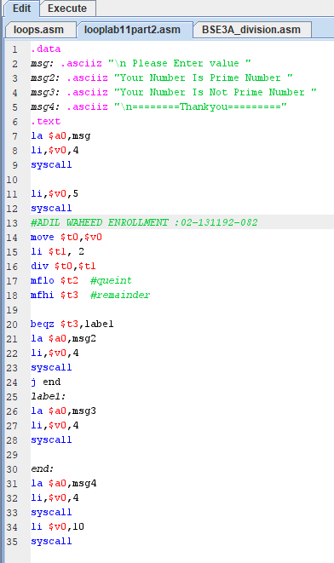

**OUTPUT:**

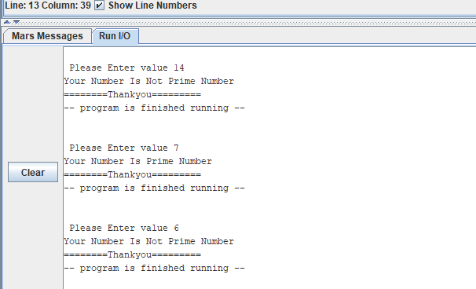

**TASK NO 2: Write a program in MIPS assembly language that provide the sum from 1 to 99 using for Loop**

**SOLUTION:**

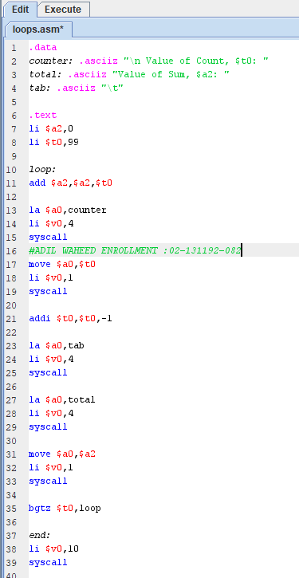

**OUTPUT:**

Value of Count, $t0: 99 Value of Sum, $a2: 99

Value of Count, $t0: 98 Value of Sum, $a2: 197

Value of Count, $t0: 97 Value of Sum, $a2: 294

Value of Count, $t0: 96 Value of Sum, $a2: 390

Value of Count, $t0: 95 Value of Sum, $a2: 485

Value of Count, $t0: 94 Value of Sum, $a2: 579

Value of Count, $t0: 93 Value of Sum, $a2: 672

Value of Count, $t0: 92 Value of Sum, $a2: 764

Value of Count, $t0: 91 Value of Sum, $a2: 855

Value of Count, $t0: 90 Value of Sum, $a2: 945

Value of Count, $t0: 89 Value of Sum, $a2: 1034

Value of Count, $t0: 88 Value of Sum, $a2: 1122

Value of Count, $t0: 87 Value of Sum, $a2: 1209

Value of Count, $t0: 86 Value of Sum, $a2: 1295

Value of Count, $t0: 85 Value of Sum, $a2: 1380

Value of Count, $t0: 84 Value of Sum, $a2: 1464

Value of Count, $t0: 83 Value of Sum, $a2: 1547

Value of Count, $t0: 82 Value of Sum, $a2: 1629

Value of Count, $t0: 81 Value of Sum, $a2: 1710

Value of Count, $t0: 80 Value of Sum, $a2: 1790

Value of Count, $t0: 79 Value of Sum, $a2: 1869

Value of Count, $t0: 78 Value of Sum, $a2: 1947

Value of Count, $t0: 77 Value of Sum, $a2: 2024

Value of Count, $t0: 76 Value of Sum, $a2: 2100

Value of Count, $t0: 75 Value of Sum, $a2: 2175

Value of Count, $t0: 74 Value of Sum, $a2: 2249

Value of Count, $t0: 73 Value of Sum, $a2: 2322

Value of Count, $t0: 72 Value of Sum, $a2: 2394

Value of Count, $t0: 71 Value of Sum, $a2: 2465

Value of Count, $t0: 70 Value of Sum, $a2: 2535

Value of Count, $t0: 69 Value of Sum, $a2: 2604

Value of Count, $t0: 68 Value of Sum, $a2: 2672

Value of Count, $t0: 67 Value of Sum, $a2: 2739

Value of Count, $t0: 66 Value of Sum, $a2: 2805

Value of Count, $t0: 65 Value of Sum, $a2: 2870

Value of Count, $t0: 64 Value of Sum, $a2: 2934

Value of Count, $t0: 63 Value of Sum, $a2: 2997

Value of Count, $t0: 62 Value of Sum, $a2: 3059

Value of Count, $t0: 61 Value of Sum, $a2: 3120

Value of Count, $t0: 60 Value of Sum, $a2: 3180

Value of Count, $t0: 59 Value of Sum, $a2: 3239

Value of Count, $t0: 58 Value of Sum, $a2: 3297

Value of Count, $t0: 57 Value of Sum, $a2: 3354

Value of Count, $t0: 56 Value of Sum, $a2: 3410

Value of Count, $t0: 55 Value of Sum, $a2: 3465

Value of Count, $t0: 54 Value of Sum, $a2: 3519

Value of Count, $t0: 53 Value of Sum, $a2: 3572

Value of Count, $t0: 52 Value of Sum, $a2: 3624

Value of Count, $t0: 51 Value of Sum, $a2: 3675

Value of Count, $t0: 50 Value of Sum, $a2: 3725

Value of Count, $t0: 49 Value of Sum, $a2: 3774

Value of Count, $t0: 48 Value of Sum, $a2: 3822

Value of Count, $t0: 47 Value of Sum, $a2: 3869

Value of Count, $t0: 46 Value of Sum, $a2: 3915

Value of Count, $t0: 45 Value of Sum, $a2: 3960

Value of Count, $t0: 44 Value of Sum, $a2: 4004

Value of Count, $t0: 43 Value of Sum, $a2: 4047

Value of Count, $t0: 42 Value of Sum, $a2: 4089

Value of Count, $t0: 41 Value of Sum, $a2: 4130

Value of Count, $t0: 40 Value of Sum, $a2: 4170

Value of Count, $t0: 39 Value of Sum, $a2: 4209

Value of Count, $t0: 38 Value of Sum, $a2: 4247

Value of Count, $t0: 37 Value of Sum, $a2: 4284

Value of Count, $t0: 36 Value of Sum, $a2: 4320

Value of Count, $t0: 35 Value of Sum, $a2: 4355

Value of Count, $t0: 34 Value of Sum, $a2: 4389

Value of Count, $t0: 33 Value of Sum, $a2: 4422

Value of Count, $t0: 32 Value of Sum, $a2: 4454

Value of Count, $t0: 31 Value of Sum, $a2: 4485

Value of Count, $t0: 30 Value of Sum, $a2: 4515

Value of Count, $t0: 29 Value of Sum, $a2: 4544

Value of Count, $t0: 28 Value of Sum, $a2: 4572

Value of Count, $t0: 27 Value of Sum, $a2: 4599

Value of Count, $t0: 26 Value of Sum, $a2: 4625

Value of Count, $t0: 25 Value of Sum, $a2: 4650

Value of Count, $t0: 24 Value of Sum, $a2: 4674

Value of Count, $t0: 23 Value of Sum, $a2: 4697

Value of Count, $t0: 22 Value of Sum, $a2: 4719

Value of Count, $t0: 21 Value of Sum, $a2: 4740

Value of Count, $t0: 20 Value of Sum, $a2: 4760

Value of Count, $t0: 19 Value of Sum, $a2: 4779

Value of Count, $t0: 18 Value of Sum, $a2: 4797

Value of Count, $t0: 17 Value of Sum, $a2: 4814

Value of Count, $t0: 16 Value of Sum, $a2: 4830

Value of Count, $t0: 15 Value of Sum, $a2: 4845

Value of Count, $t0: 14 Value of Sum, $a2: 4859

Value of Count, $t0: 13 Value of Sum, $a2: 4872

Value of Count, $t0: 12 Value of Sum, $a2: 4884

Value of Count, $t0: 11 Value of Sum, $a2: 4895

Value of Count, $t0: 10 Value of Sum, $a2: 4905

Value of Count, $t0: 9 Value of Sum, $a2: 4914

Value of Count, $t0: 8 Value of Sum, $a2: 4922

Value of Count, $t0: 7 Value of Sum, $a2: 4929

Value of Count, $t0: 6 Value of Sum, $a2: 4935

Value of Count, $t0: 5 Value of Sum, $a2: 4940

Value of Count, $t0: 4 Value of Sum, $a2: 4944

Value of Count, $t0: 3 Value of Sum, $a2: 4947

Value of Count, $t0: 2 Value of Sum, $a2: 4949

Value of Count, $t0: 1 Value of Sum, $a2: 4950

-- program is finished running --